TITLE: A Real-Time Video Surveillance System for Detection of Abandoned Objects
ABSTRACT

This project presents VigiLens, a Real-Time Video Surveillance System designed to automatically detect abandoned objects in public environments. The system captures live video through a webcam or recorded CCTV footage and processes each frame to identify persons and objects such as bags, backpacks, and suitcases. An ownership association module links each detected object to its nearest person and monitors the distance between them. When the owner moves beyond a defined threshold and the object remains unattended for a specified duration, the system triggers an alert with a red bounding box and warning message on the dashboard. The system is built using Python, YOLOv8, OpenCV, and PyQt5 and is deployed as a standalone Windows desktop application.

Mr. K Rupesh Reddy Dr. Almas Begum

THE FIELD OF INVENTION
The field of invention pertains to artificial intelligence, computer vision, and intelligent video surveillance systems. This invention specifically relates to a method and system for automatically detecting abandoned or unattended objects in real-time video feeds using deep learning-based object detection and a novel ownership association mechanism that links detected objects to nearby persons and monitors their spatial separation over time.

BACKGROUND OF THE INVENTION
The present invention relates to intelligent video surveillance and specifically to a real-time system capable of automatically detecting abandoned objects in live or recorded video streams. Traditional closed-circuit television systems deployed in public spaces such as airports, railway stations, and shopping malls are passive recording tools that rely entirely on continuous manual monitoring by security personnel. This approach suffers from significant limitations including human fatigue, reduced attention during extended monitoring periods, inability to simultaneously observe multiple camera feeds, and delayed response when suspicious events occur.
Recent developments in deep learning and computer vision have introduced object detection frameworks capable of identifying and classifying objects in real time. However, existing commercial surveillance solutions incorporating such technologies are expensive, require complex server infrastructure, and are inaccessible to small institutions and budget constrained organizations. Furthermore, most existing detection systems that identify stationary objects do not incorporate an ownership association mechanism capable of linking a specific object to a nearby person and tracking their spatial relationship over time. Without such a mechanism, systems generate excessive false alarms for objects that are temporarily stationary but remain attended by their owners. The VigiLens system addresses all of these limitations through an affordable, intelligent, and lightweight standalone desktop application.

Mr. K Rupesh Reddy Dr. Almas Begum
SUMMARY OF THE INVENTION
The invention is a standalone Windows desktop application named VigiLens that uses a deep learning object detection engine combined with a proprietary ownership association module to automatically detect abandoned objects in real-time video feeds. The system identifies persons and objects in each video frame, assigns each detected object to its nearest person as its owner, and continuously monitors the distance between them. When an object becomes disassociated from its owner beyond a defined spatial threshold and remains unattended for a configurable duration, the system classifies it as abandoned and generates immediate visual and logged alerts. The system supports both live webcam input and pre-recorded CCTV video files and is packaged as a single Windows executable requiring no external dependencies.

Mr. K Rupesh Reddy Dr. Almas Begum
SPECIFICATION
- The system performs real-time object detection on each video frame to identify and classify persons, backpacks, handbags, and suitcases using a pretrained deep learning model with confidence threshold filtering above 0.5.
- An ownership association module calculates the Euclidean distance between the centroid of each detected object and all detected persons in the same frame, assigning the nearest person as the owner of that object.
- An abandonment detection module initiates a timer when the distance between an object and its assigned owner exceeds a configurable pixel threshold, classifying the object as abandoned when the timer exceeds a configurable duration.
- A multi-modal alert system generates a red bounding box overlay on the suspicious object, displays a timestamped warning message on the dashboard, and records an entry in the alert history log upon confirmed abandonment detection.
- The system includes an operator acknowledgement and alert reset feature that allows security personnel to manually verify and clear alerts after physical confirmation.
- The application supports dual input modes comprising live webcam capture and pre-recorded CCTV video file playback within the same interface.
- The complete application is packaged as a standalone Windows executable requiring no additional software installation, Python runtime, or external library dependencies on the target machine.

Mr. K Rupesh Reddy Dr. Almas Begum
DESCRIPTION
The "Wearable Smart Backpack with Integrated Automatic Umbrella" is an innovative accessory that combines the functionality of a backpack with the convenience of an automatic umbrella system. The backpack features a retractable umbrella housed within its structure, which can be deployed with a simple push of a button, offering users immediate weather protection without the need for carrying a separate umbrella. Designed for comfort, the backpack includes adjustable straps and breathable materials, ensuring a snug fit during extended use. The umbrella mechanism is powered by an integrated power source, making it easy to operate when needed. The sleek and modern design of the backpack maintains a balance between style and practicality, allowing users to carry their essentials while staying dry in adverse weather conditions. The system is lightweight, easy to use, and simple to install, making it an ideal solution for active individuals seeking both convenience and protection from the elements.
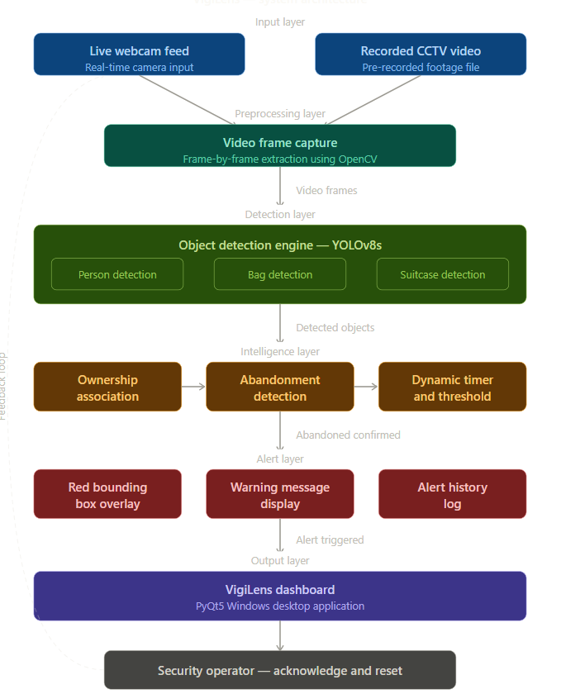
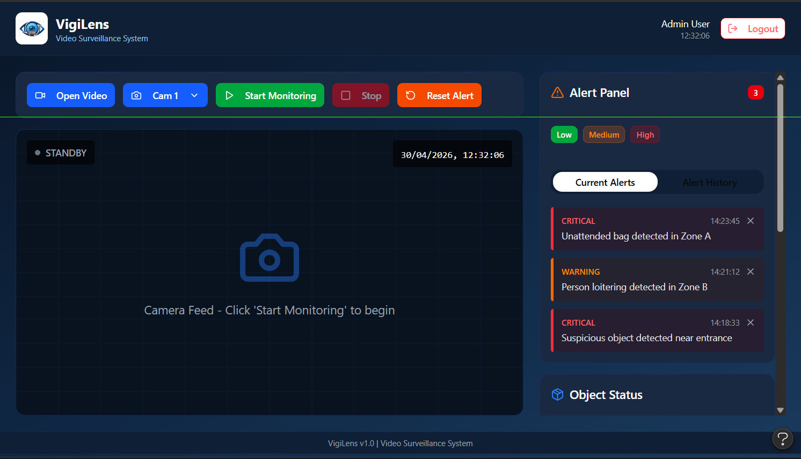
Figure 1:System Architecture Diagram of Vigilens — Real-Time Video Surveillance System for Detection of Abandoned Objects
Figure 2: Dashboard Interface of Vigilens — Real-Time Video Surveillance System for Detection of Abandoned Objects

Mr. K Rupesh Reddy Dr. Almas Begum
WE CLAIM
- Claim: A wearable smart backpack comprising an integrated retractable automatic umbrella, the umbrella being housed within a compartment of the backpack and capable of being deployed with a single button press.
- Claim: The wearable smart backpack of claim 1, wherein the backpack includes adjustable straps and breathable materials for ergonomic comfort during extended wear.
- Claim: The wearable smart backpack of claim 1, further including a power source for operating the automatic umbrella, ensuring seamless deployment when needed.
- Claim: The wearable smart backpack of claim 1, wherein the retractable umbrella is designed to retract into a compact, streamlined compartment to maintain the aesthetic appearance of the backpack when not in use.
- Claim: The wearable smart backpack of claim 1, wherein the umbrella is activated by a push button integrated into the backpack, providing ease of use.
- Claim: The wearable smart backpack of claim 1, wherein the umbrella provides protection from adverse weather conditions, including rain and snow.
- Claim: The wearable smart backpack of claim 1, wherein the backpack’s materials are durable, lightweight, and weather-resistant, ensuring long-lasting use and protection in various environmental conditions.

Mr. K Rupesh Reddy Dr. Almas Begum

